Page 1/2

TIPS FOR OPTIMISING BATTERY LIFE
- The escape batteries are Lithium-Ferrite batteries. They have the advantage over Lithium-ion batteries that they have 2000 charging cycles instead of 500.
- Ideally, each charge cycle should be used up to 5% to 10% before recharging via power cord. Level easily verified via our App "Escape Remote" (see detailed manual for charging our App or via our support section at www.escapespeakers.com) Each time the device is connected with the power cord, a charging cycle is used.
- When not using the speaker via battery for a long time, it is best to remove the battery 100 % charged from the device and store it somewhere dry and at room temperature.
Replacing the battery
- Disconnect the Escape® P9 from the wall socket.
- Carefully lay the Escape® P9 on its side on a flat, clean surface.

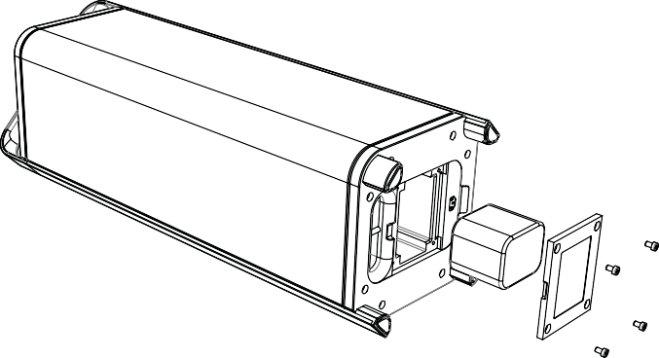
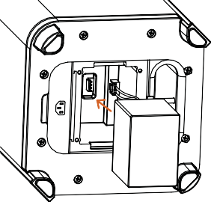
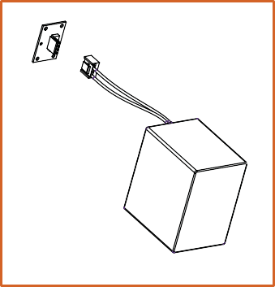
To remove the battery, press the locking tab and pull the battery connector out of the internal male connector.

See reverse side for continuation.

Page 2/2

- Remove the battery cover screws and remove the cover.
- Remove the battery and disconnect the female battery connector from the internal male connector.
- Plug the socket of the spare battery back into the internal connector. Make sure that the Molex-connector is oriented correctly to connect this type of connector properly. Gently push the plugin. Do not force the plug in.
The plug can only be connected in one direction. Be careful not to reverse the polarity. Failure to do so may result in permanent damage to the internal electronics and repair costs that are not covered by the warranty.
- Now screw the battery cover back into it’s place.

CAUTION : Replace the battery only with an original Escape™ P9 battery. As
with all batteries, there is a risk of explosion and injury if the battery is replaced
with an incorrect type.

